Bandit OverTheWire Writeup:
Level 0:
Task :
The goal of this level is for you to log into the game using SSH. The host to which you need to connect is bandit.labs.overthewire.org, on port 2220. The username is bandit0 and the password is bandit0. Once logged in, go to the Level 1 page to find out how to beat Level 1.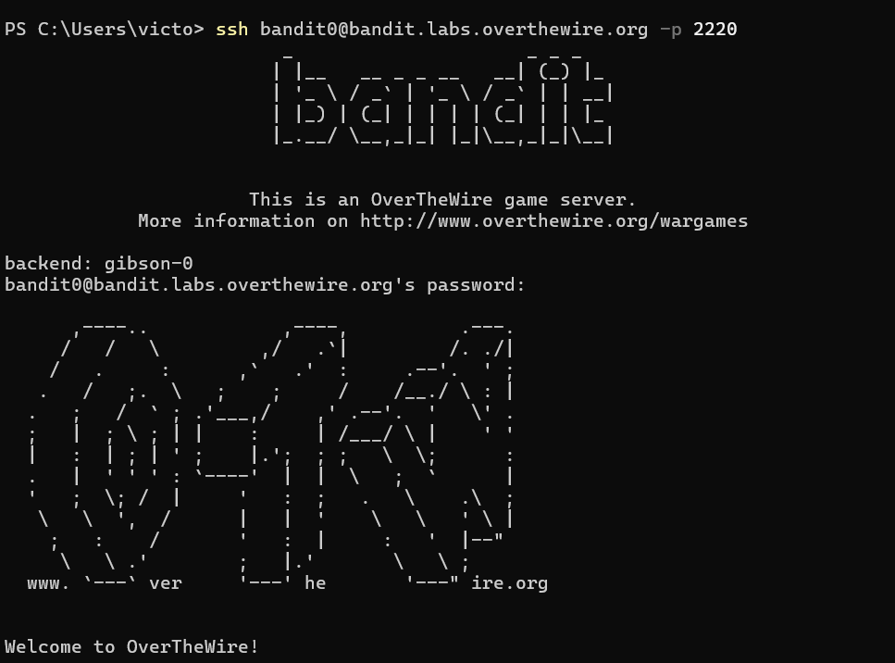
Log into the level with ssh in server:bandit.labs.overthewire.org in the port 2220 . command : ssh bandit0@bandit.labs.overthewire.org -p 2220
username : bandit0
password : bandit0
Level 0 - 1:
Task :The password for the next level is stored in a file called readme located in the home directory. Use this password to log into bandit1 using SSH. Whenever you find a password for a level, use SSH on port 2220 to log into that level and continue the game. 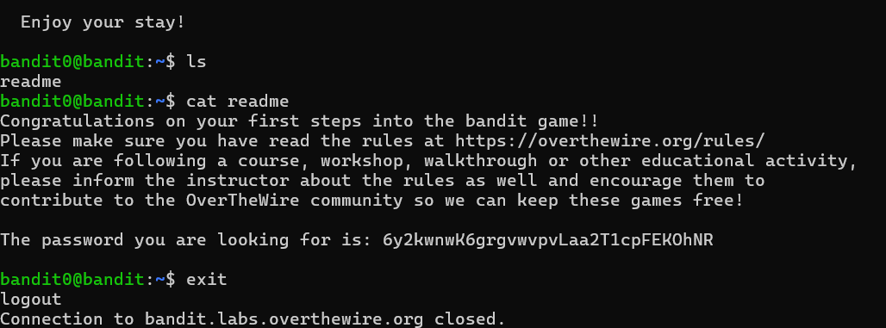
After entering the bandit0 use ls to view the directories. Use cat to view the content of the readme file.
Command : ls and cat readme
Password : 6y2kwnwK6grgvwvpvLaa2T1cpFEKOhNR
Level 1 - 2:
Task : The password for the next level is stored in a file called - located in the home directory
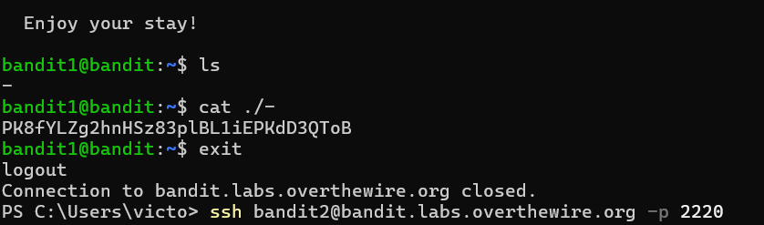
Using the previous level passkey the current level is accessed and password for next level is is in a file called - . use ls and cat to get the password.
Command : ls and cat ./-
Password : PK8fYLZg2hnHSz83plBL1iEPKdD3QToB
Level 2 - 3:
Task : The password for the next level is stored in a file called spaces in this filename located in the home directory
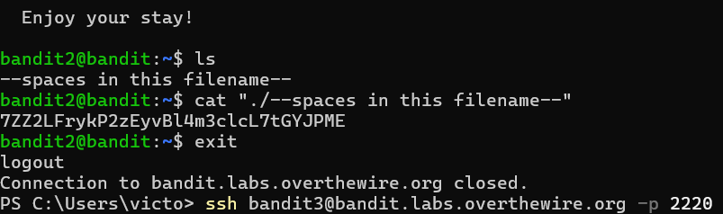
Command : ls and cat “./--spaces in this filename—" are used.
Password : 7ZZ2LFrykP2zEyvBl4m3clcL7tGYJPME
Level 3 - 4:
Task : The password for the next level is stored in a hidden file in the inhere directory.
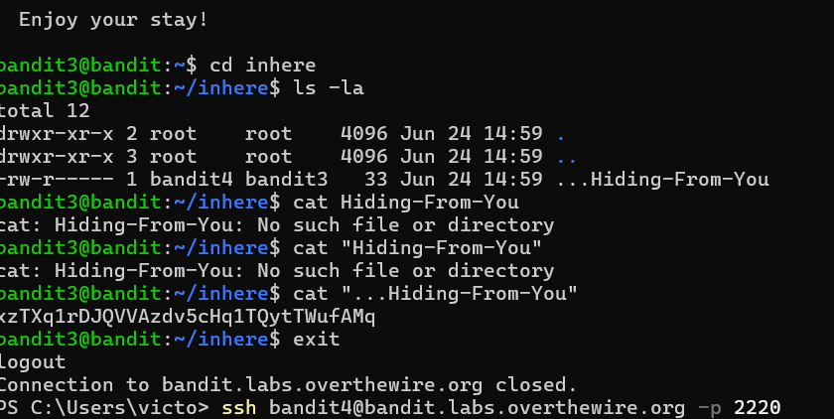
In this level the password is hidden inside the directory inhere.
Command : cd inhere, ls -la and cat <filename>
Password : xzTXq1rDJQVVAzdv5cHq1TQytTWufAMq
Level 4 - 5:
Task : The password for the next level is stored in the only human-readable file in the inhere directory.
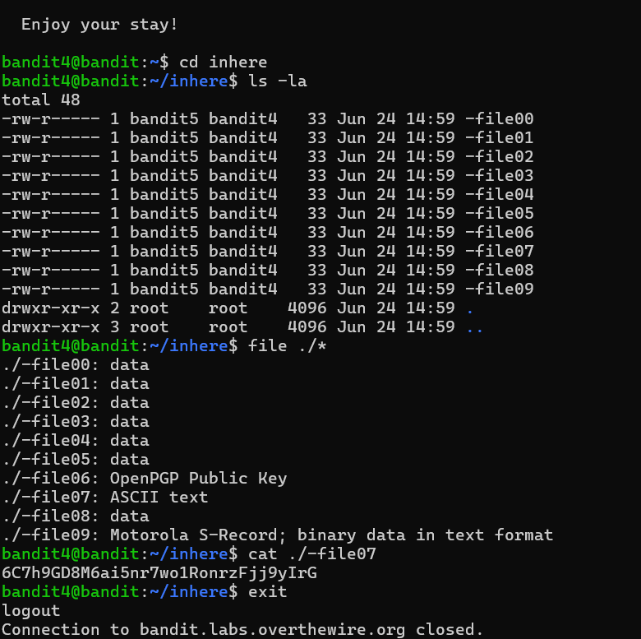
In this level the directories as many files in which the password is in the human readable file. the command find is used to get the readable file in the directory. Command : cd inhere, la -la, file ./* and cat <filename>
Password : 6C7h9GD8M6ai5nr7wo1RonrzFjj9yIrG
Level 5 - 6 :
Task : The password for the next level is stored in a file somewhere under the inhere directory and has all of the following properties: human-readable, 1033 bytes in size, not executable
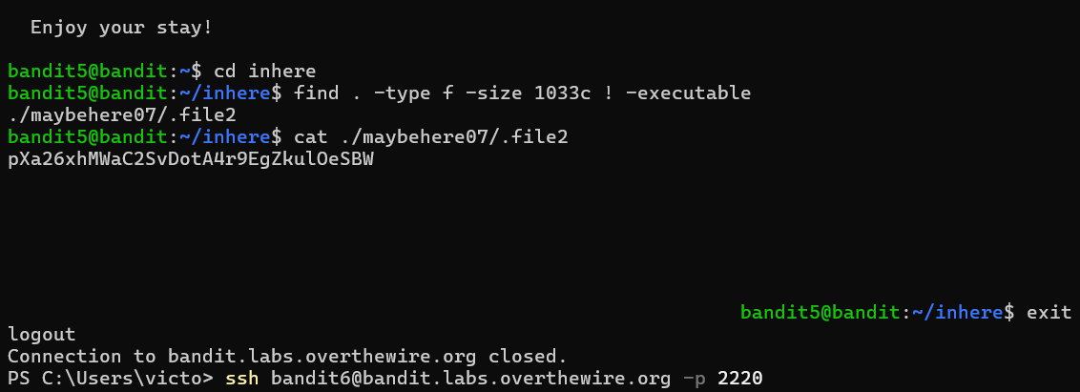
Command : find . -type f -size 1033c ! -executable
Password : pXa26xhMWaC2SvDotA4r9EgZkulOeSBW
Level 6 - 7:
Task : The password for the next level is stored somewhere on the server and has all of the following properties: owned by user bandit7, owned by group bandit6, 33 bytes in size
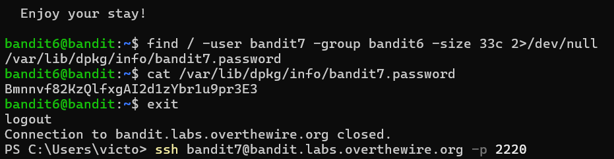
Command : find / -user bandit7 -group bandit6 -size 33c 2>/dev/null
Password : Bmnnvf82KzQlfxgAI2d1zYbr1u9pr3E3

Level 7 - 8 :
Task : The password for the next level is stored in the file data.txt next to the word millionth
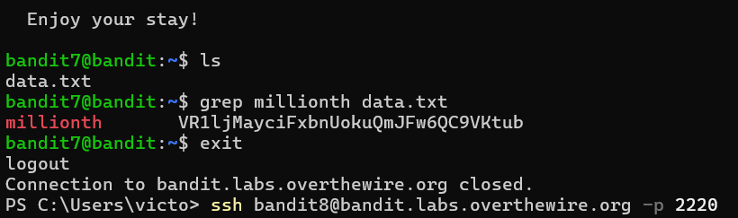
The data.txt file has many strings which are difficult to find .
Command : grep millionth data.txt
Password : VR1ljMayciFxbnUokuQmJFw6QC9VKtub
Level 8 - 9:
Task : The password for the next level is stored in the file data.txt and is the only line of text that occurs only once
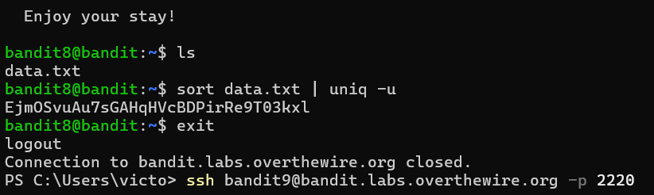
Command : sort data.txt | uniq -u
Password : EjmOSvuAu7sGAHqHVcBDPirRe9T03kxl
Level 9 - 10 :
Task : The password for the next level is stored in the file data.txt in one of the few humanreadable strings, preceded by several ‘=ʼ characters.
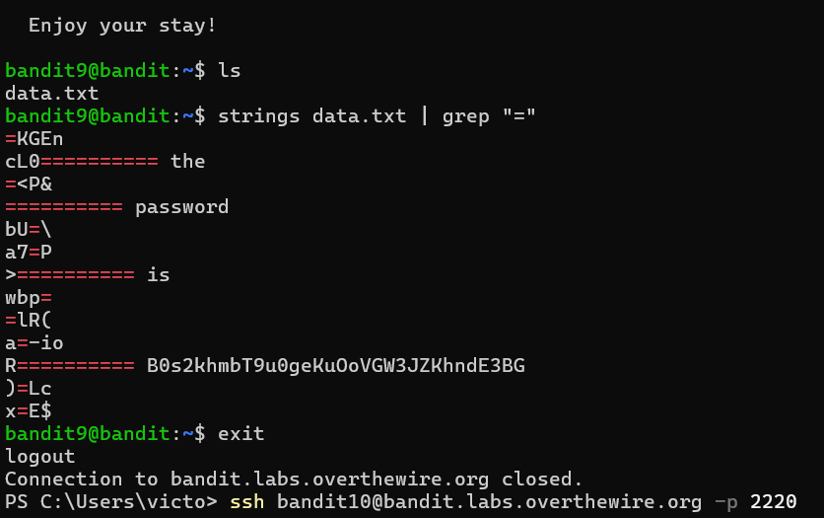
strings data.txt gives the whole strings content of the file but the | grep “=ˮ gives the strings which has the characters.
Command : strings data.txt | grep “=ˮ
Password : B0s2khmbT9u0geKuOoVGW3JZKhndE3BG
Level 10 - 11 :
Task : The password for the next level is stored in the file data.txt, which contains base64 encoded data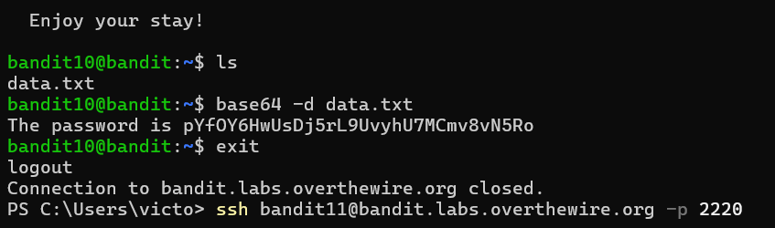
Command : base64 -d data.txt
Password : pYfOY6HwUsDj5rL9UvyhU7MCmv8vN5Ro
Level 11 - 12 :
Task : The password for the next level is stored in the file data.txt, where all lowercase (a-z) and uppercase letters have been rotated by 13 positions.
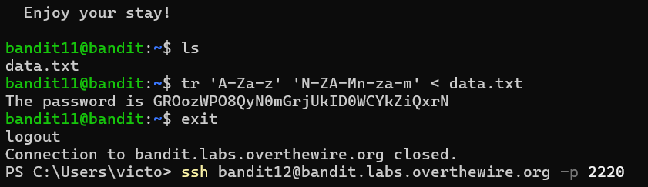
Command : tr ‘A-Za-z’ ‘N-ZA-Mn-za-m’ < data.txt
Password : GROozWPO8QyN0mGrjUkID0WCYkZiQxrN
Level 12 - 13 :
Task : The password for the next level is stored in the file data.txt, which is a hexdump of a file that has been repeatedly compressed. For this level it may be useful to create a directory under /tmp in which you can work. Use mkdir with a hard to guess directory name.
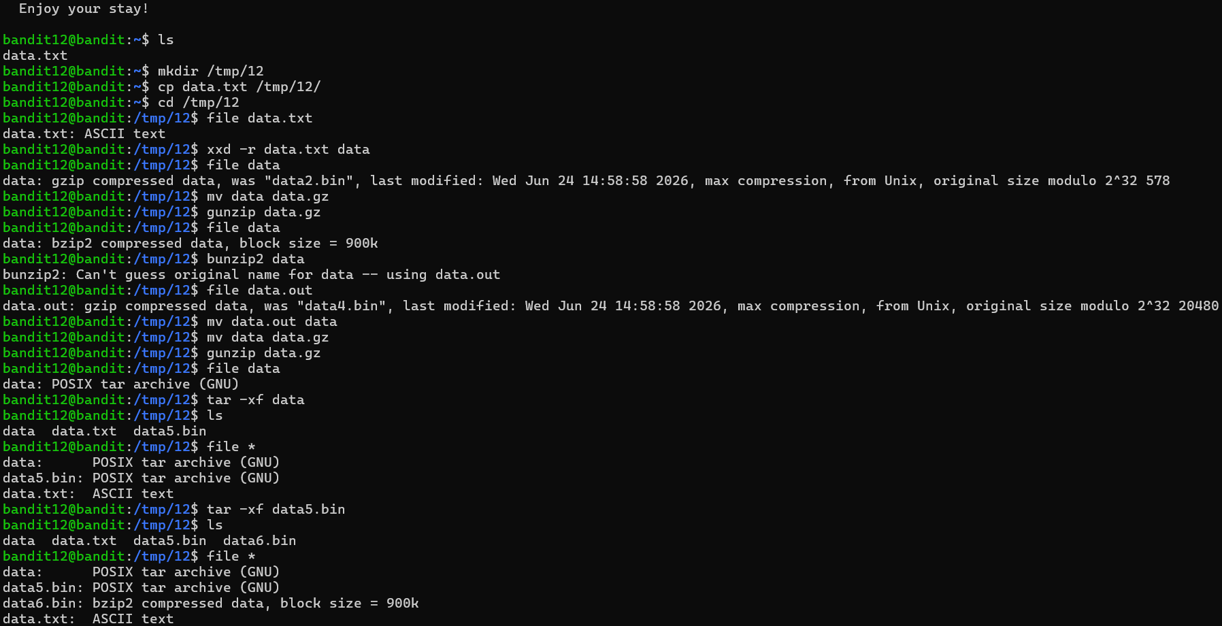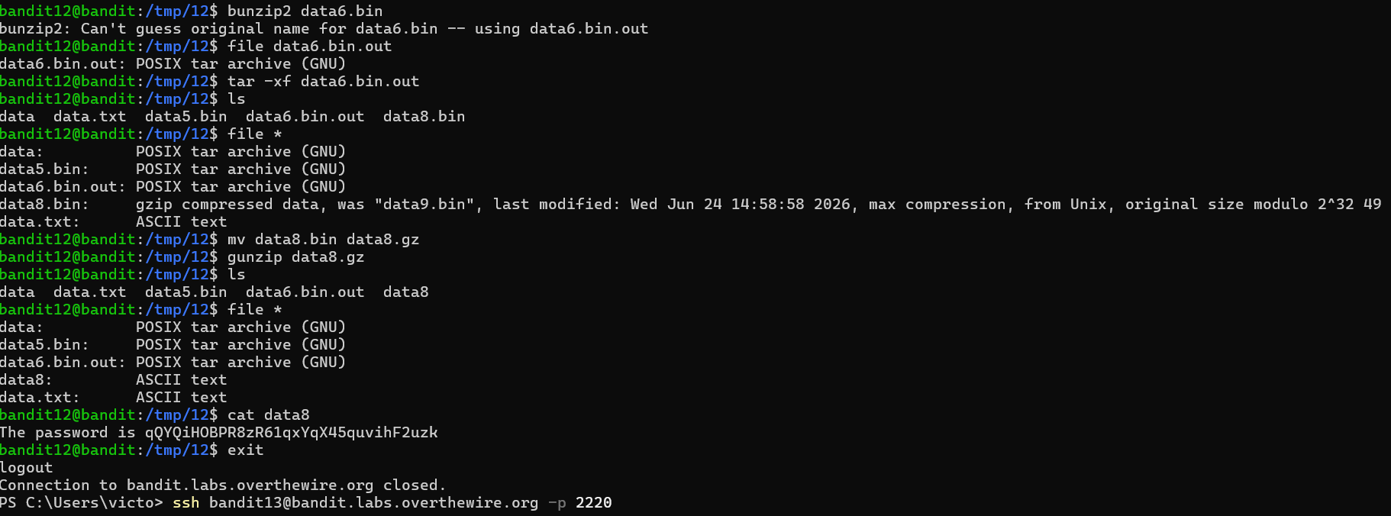
Commands : mkdir /tmp/<name>, cp data.txt <dir>, cd <dir>, xxd -r data.txt data
For gunzip : mv data data.gz, gunzip data.gz, and file data
For bunzip2 : bunzip2 data, file data.out
For tar : tar -xf data, ls and file *
Password : qQYQiHOBPR8zR61qxYqX45quvihF2uzk
Level 13 - 14 :
Task : The password for the next level is stored in /etc/bandit_pass/bandit14 and can only be read by user bandit14. For this level, you donʼt get the next password, but you get a private SSH key that can be used to log into the next level. Note: localhost is a hostname that refers to the machine you are working on. 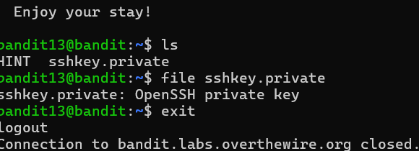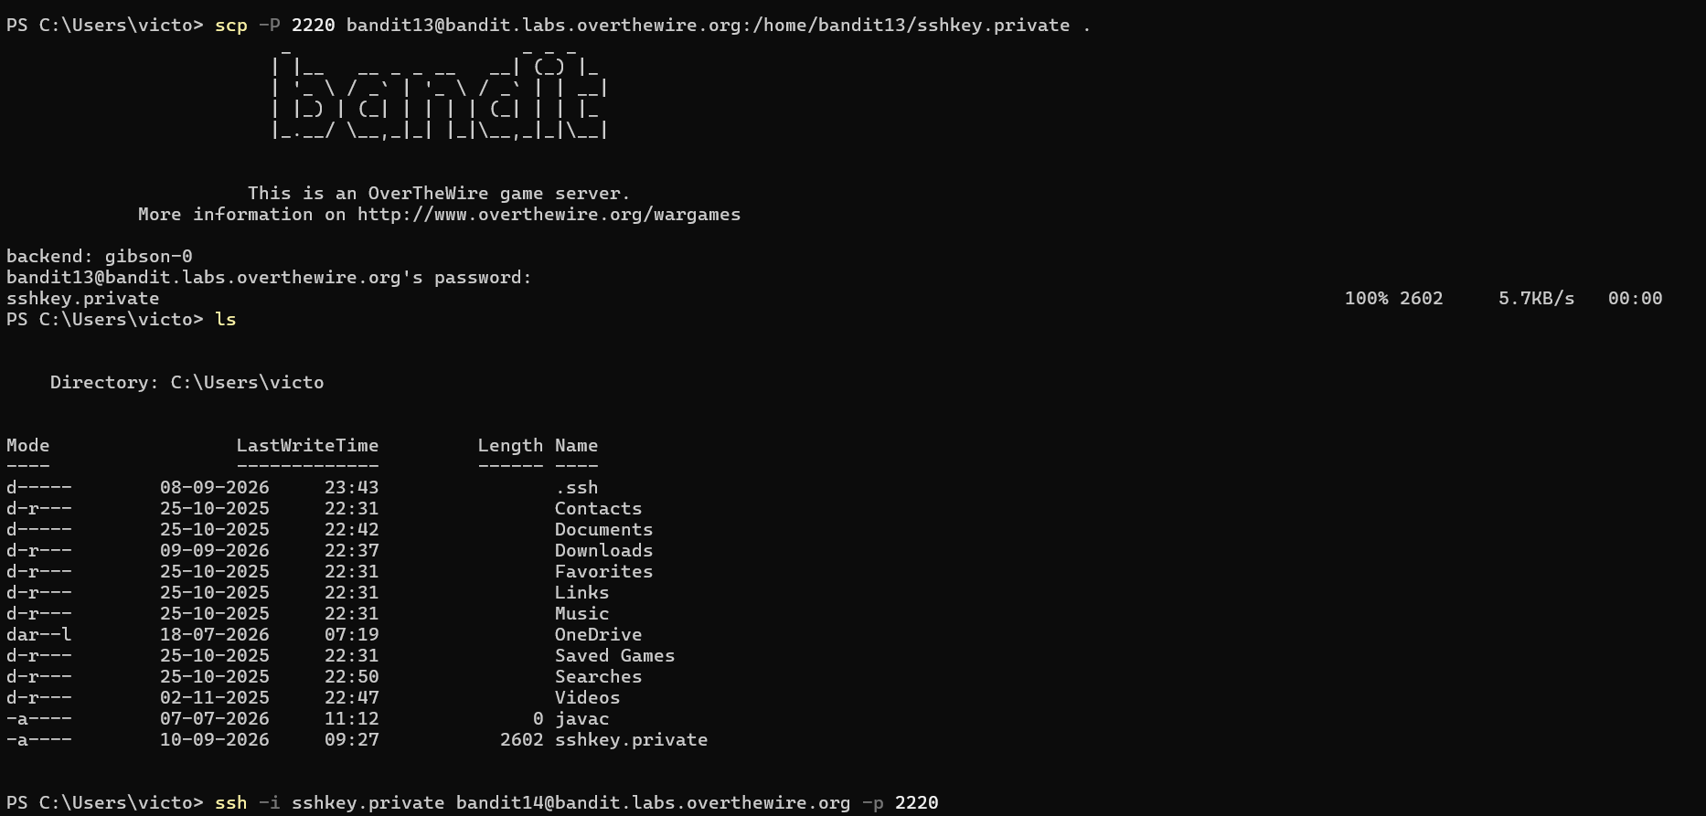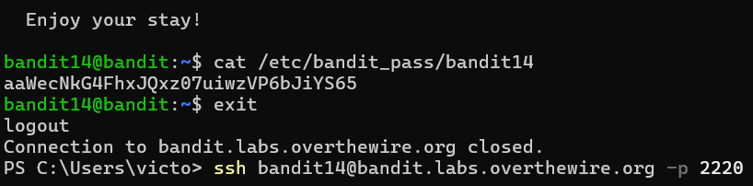
Command : scp -P 2220 bandit13@bandit.labs.overthewire.org:/home/bandit13/sshkey.private and ssh -i sshkey.private bandit14@bandit.labs.overthewire.org -p 2220
Password : aaWecNkG4FhxJQxz07uiwzVP6bJiYS65
Level 13 - 14 :
Task : The password for the next level can be retrieved by submitting the password of the current level to port 30000 on localhost.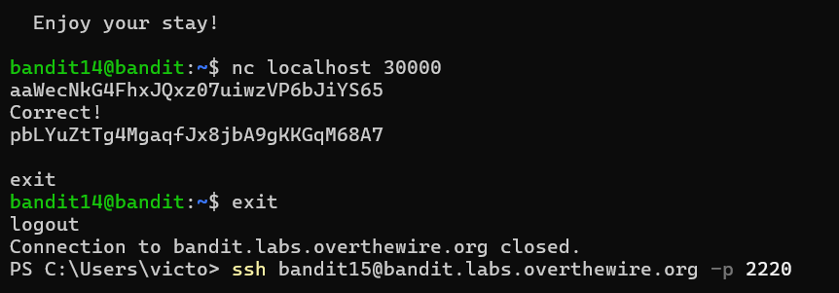
Command : nc localhost 30000
Password : pbLYuZtTg4MgaqfJx8jbA9gKKGqM68A7
Level 15 - 16 :
Task : The password for the next level can be retrieved by submitting the password of the current level to port 30001 on localhost using SSL/TLS encryption.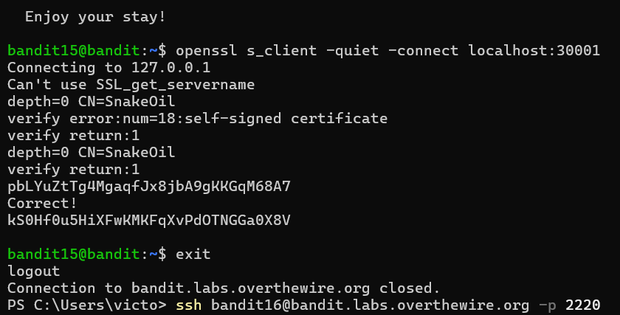
The password for next level is derived by giving the password for current level.
Command : openssl s_client -quiet -connect localhost 30001
Password : kS0Hf0u5HiXFwKMKFqXvPdOTNGGa0X8V

